Name: _____________________

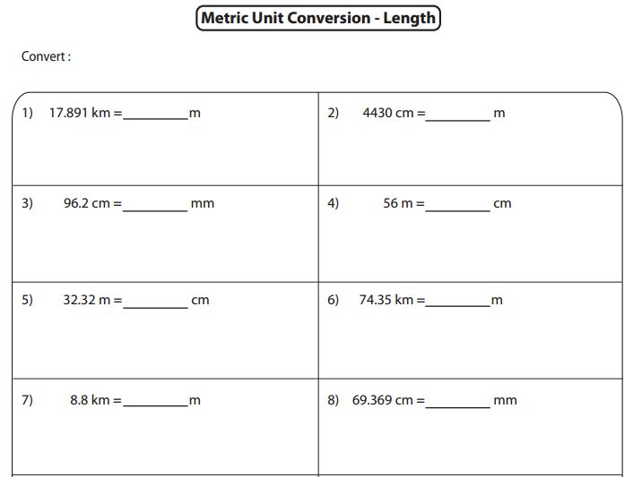Directions: Multiply or divide to convert from one unit to another.

